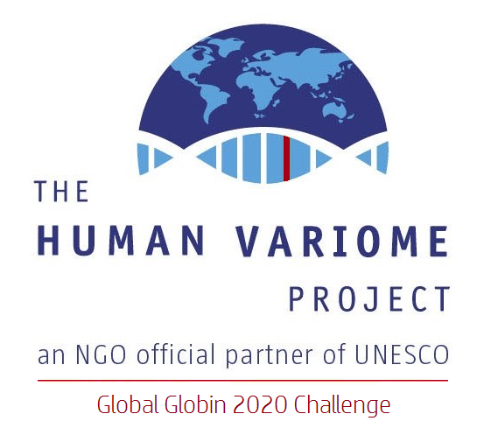

IthaMaps Submission Form
(please return the completed form to petrosk@cing.ac.cy)

COUNTRY:

A. Contributor’s details
(to be included in ITHANET Organisations & Experts)

Name
Surname
Title
Expertise / research interests
Address
E-mail address
ORCID, if available
(http://orcid.org/)
ResearcherID, if available
(http://www.researcherid.com/ )
Organisation’s name
Organisation’s brief description
Organisation’s address
Organisation’s website

Note:
The information you provide for the specific country will appear on the IthaMaps website and your contribution will be acknowledged.
B. Healthcare policies
Health-policy | Select ONE Answer | Comment
Prevention programme | YES (National)  YES (Regional)  NO
SCD Newborn Screening | YES (National)  YES (Regional)  NO
Prenatal Screening | YES (National)  YES (Regional)  NO
Antenatal Screening | YES (National)  YES (Regional)  NO
Haemoglobinopathy patient registry | YES (National)  YES (Regional)  NO
Rare disease patient registry | YES (National)  YES (Regional)  NO
Dedicated treatment centres | YES (National)  YES (Regional)  NO
Blood transfusion availability | YES (National)  YES (Regional)  NO
Iron chelation availability | YES (National)  YES (Regional)  NO
MRI facilities | YES (National)  YES (Regional)  NO
Patient associations | YES (National)  YES (Regional)  NO
Genetic counselling | YES (National)  YES (Regional)  NO

C. Status of major haemoglobinopathies
Haemoglobinopathy | Provide Value | Comment
Prevalence of β-thalassaemia carriers | % of the population
Prevalence of sickle cell disease carriers | % of the population
Prevalence of α-thalassaemia carriers | % of the population
Prevalence of Hb E carriers | % of the population
Prevalence of Hb C carriers | % of the population
Expected incidence of β-thalassaemia | # of expected affected births / year  (without prevention)
Expected incidence of sickle cell disease | # of expected affected births / year  (without prevention)
Incidence of β-thalassaemia | # of affected births / year  (after prevention)
Incidence of sickle cell disease | # of affected births / year  (after prevention)
Incidence of Hb H disease | # of affected births /year
Known β-thalassaemia patients | # of patients
Known sickle cell disease patients | # of patients
Known Hb H disease patients | # of patients

D. Mutation Frequencies

Please provide details about publications reporting mutation frequencies in the country of reference (either country-wide studies or region-specific studies).

E. Comments/ suggestions about IthaMaps or the ITHANET Portal in general

THANK YOU FOR YOUR CONTRIBUTION

